Table 1

 

Diabetes as % of total inappropriate hospital admissions/ Cost of inappropriate diabetic admissions

Table 2

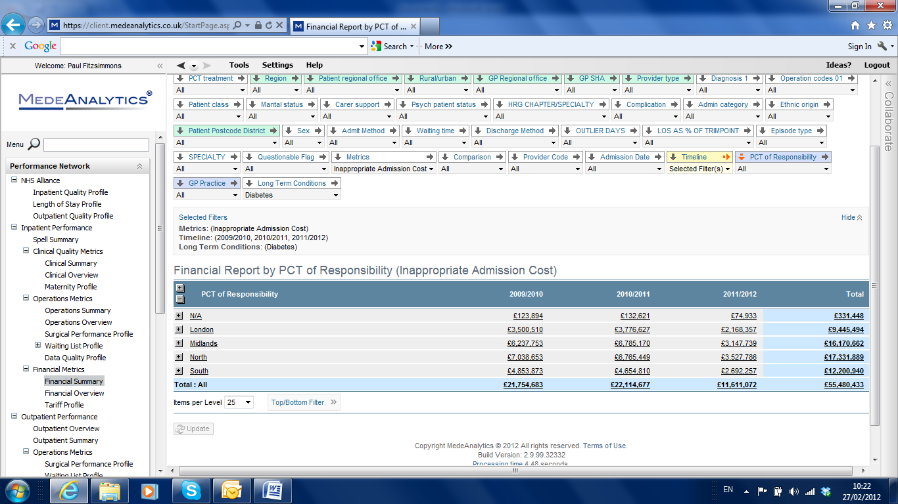

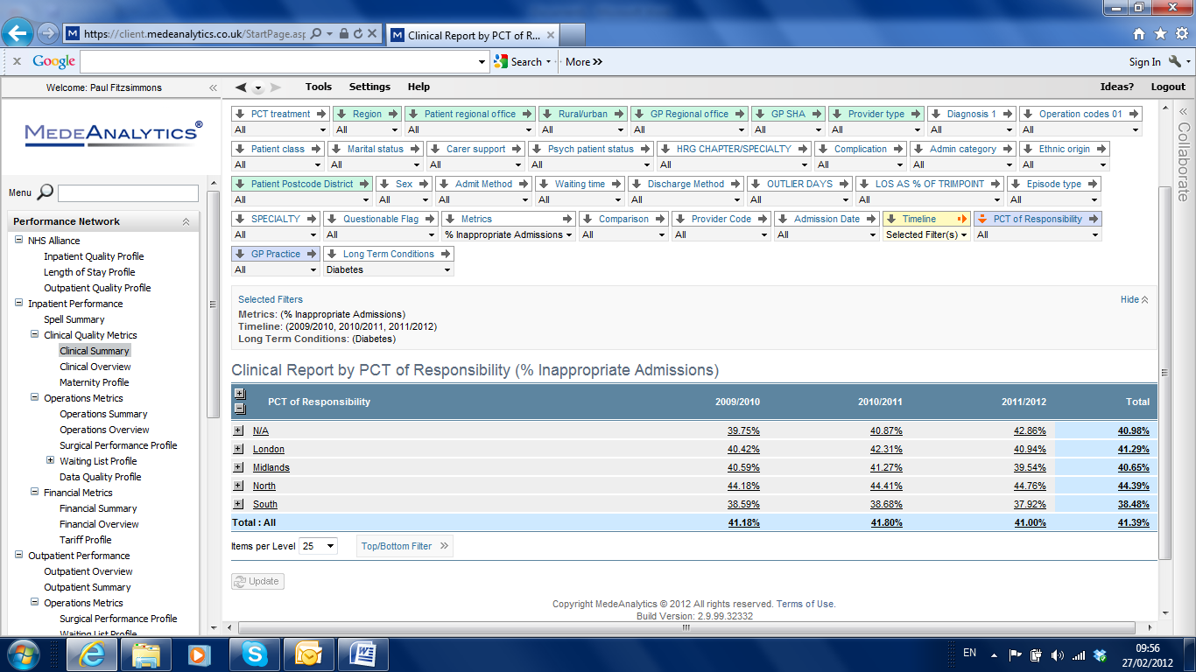

Rate of inappropriate admissions for diabetes over time by SHA Cluster

Table 3

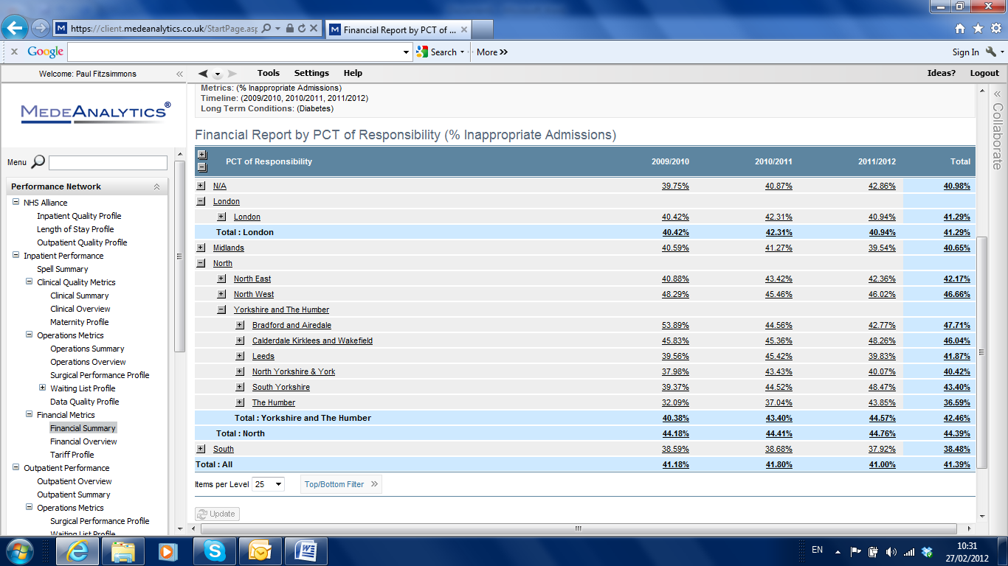

Rate of inappropriate admissions for Diabetes over time by PCT Cluster

Table 4 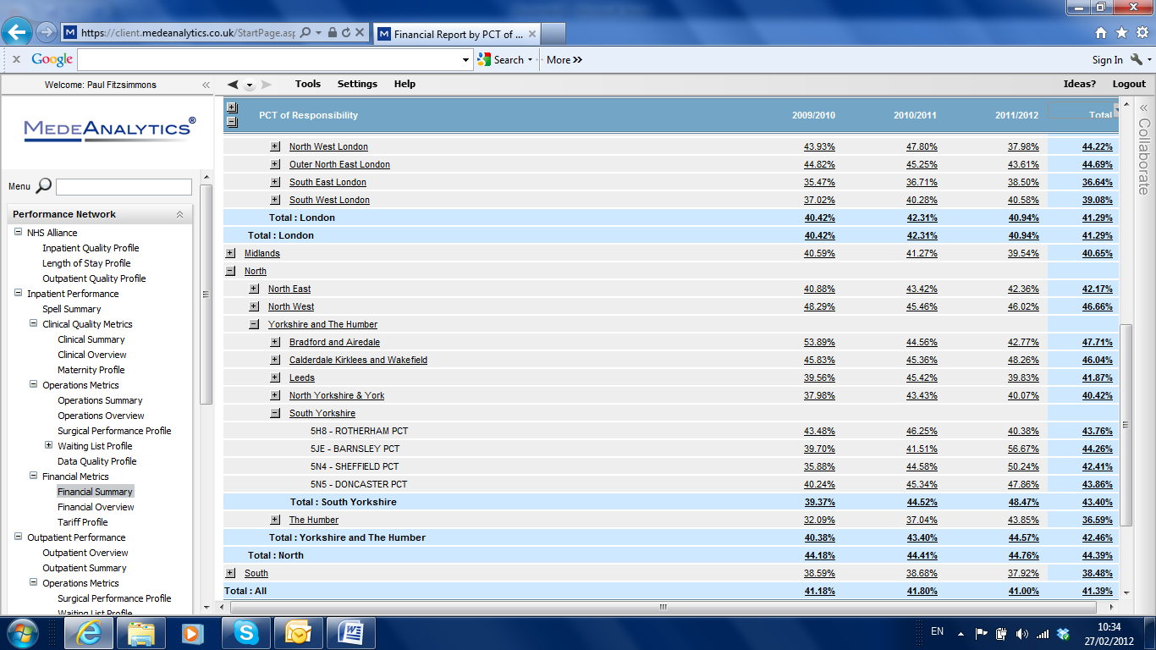



Rate of inappropriate admissions for Diabetes over time by Individual PCT

Table 5

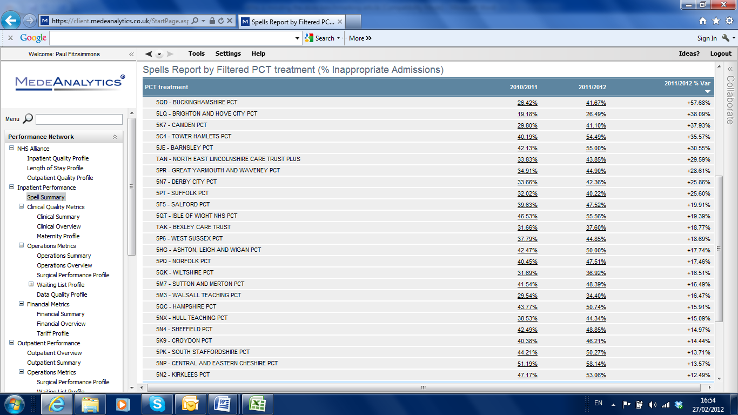

Rate of inappropriate admissions for Diabetes over time by Individual PCT

Figure 1 – diabetic patients without complications admitted into hospital

Figure 2

Figure 3

Figure 3 - Volume of cases: total and top 10 GP practices

Figure 4

***Figure 4 – Total costs and top 10 GP practices***