Table 1: RNAO survey of Ontario RNs who left Canada from year 1961 and 2000
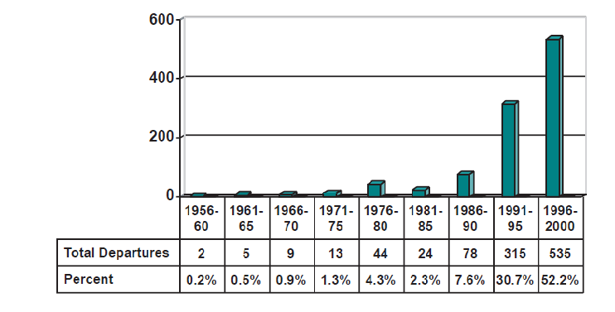
Source: RNAO, 2001

Table 2: RNAO survey on reasons why Ontario RNs left Canada
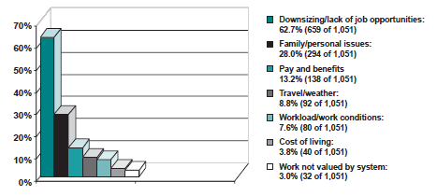
Source: RNAO, 2001

