**Figure 2 NMC Interactive Impact Framework**

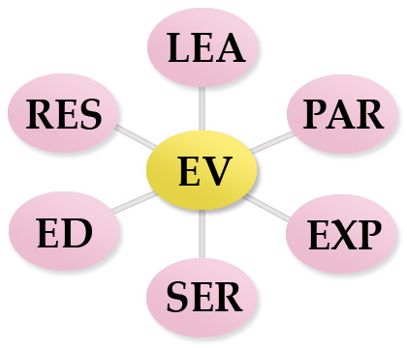

**LEA** - Clinical Leadership & Consultancy

**PAR -** Partnership/Collaborative working and empowerment of others

**EXP** - Expert Clinical Practice (Direct & Indirect)

**SER -** Service Development

**ED -** Education and Training

**RES -** Research Audit & Evaluation