## peto.co.uk logo transparent.PNG





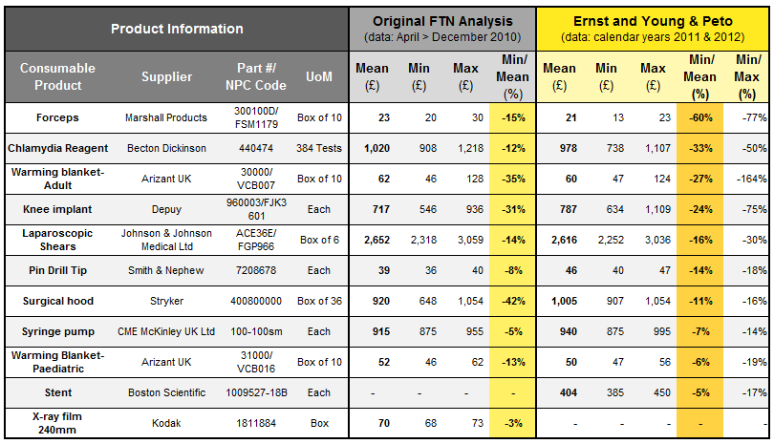

**Table 1**: Data showing data comparison for 2010 and 2011-12