

**MEDIA RELEASE**

**Monday November 14, 2011**

**NEW CHAIR FOR MENTAL HEALTH TRUST**

Ken Jarrold C.B.E. has been appointed as Chair of the North Staffordshire Combined Healthcare NHS Trust, which supports people with mental health issues, learning disabilities and needing support for drug or alcohol misuse. He takes up post on Thursday December 1, 2011.

Ken is committed to healthcare and has worked with the NHS for 42 years – 36 years in full time posts and six years in a consultancy role. His previous roles have included Chief Executive of health authorities for 20 years and he spent three years at national level as the Director of Human Resources and Deputy to the Chief Executive of the NHS in England.

Fiona Myers, Chief Executive at the Trust commented:

*“I and my colleagues are delighted to have someone of Ken’s calibre joining us here in Staffordshire.*

*“I have met with Ken and know that not only will he bring a wealth of experience to our organisation, but that he is going to be a real advocate of mental health services. He has a long standing commitment to services for people with mental illness and learning disability both as a manager and as a carer, which will prove invaluable as we move forward with our Foundation Trust application.”*

Ken has held many posts at national level including membership of the National Mental Health Task Force and Chair of the National Reference Group for Health Inequalities. In the last five years, he has held a number of non executive appointments including Board Member of the Serious Organised Crime Agency and of the Child Exploitation On Line Protection Centre [CEOP] and Chair of the County Durham Economic Partnership and of Dearden Consulting Ltd.

Ken, who lives locally, with his partner in Biddulph Moor, said:

*“It is a great privilege to have the opportunity to serve the people of Stoke on Trent, Newcastle under Lyme and the Staffordshire Moorlands and, in particular, service users and carers and our dedicated staff.*

*“I look forward to working with all our partners, including the clinical commissioning groups, local authorities, voluntary and community organisations and other NHS trusts, to provide local services for local people.”*

Sarah Boulton, Chair of NHS Midlands and East added:

*“I am delighted that Ken Jarrold CBE has today been appointed as Chair of North Staffordshire Combined Healthcare NHS Trust. Ken brings a great combination of skills, experience and commitment to the NHS to his new role which I am sure will be of enormous benefit to the Trust and it’s service users. I very much look forward to working with him in the future.”*

Appointment of all Chairs and non-executive directors to NHS trusts is the responsibility of the Appointments Commission. All non-executive appointments are made on merit and political activity plays no part in the selection process.  However, in accordance with the original Nolan recommendations, there is a requirement for appointees' political activity (if any declared) to be made public.

Mr Jarrold has no declared political activity. He will be paid £20,896 a year for this appointment. His term of office will start on December 1, 2011 and his term of office runs for four years, through to November 30, 2015.

Mr Jarrold has no other ministerial appointments. His appointment has been made in accordance with the Office of the Commissioner for Public Appointments (OCPA) Code of Practice.

[ends]

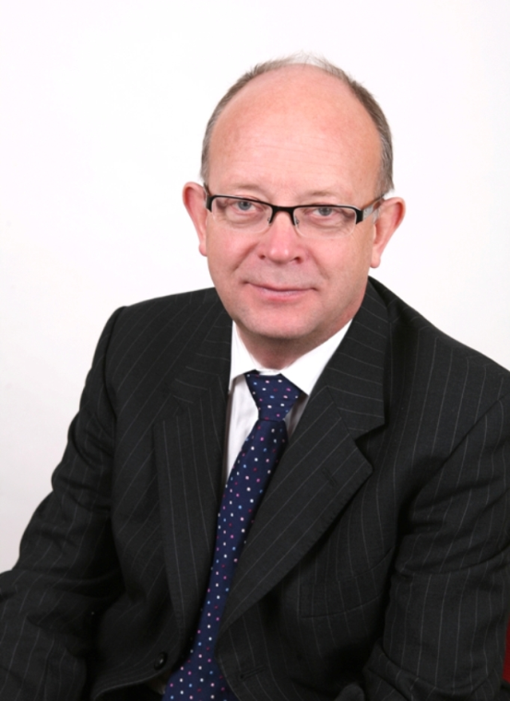

**For further information, please contact:**

Sandra Storey, Trust Secretary and Head of Corporate and Legal Affairs

North Staffordshire Combined Healthcare NHS Trust

Telephone: 01782 275025

Email: [TrustBoardEnquiries@northstaffs.nhs.uk](mailto:TrustBoardEnquiries@northstaffs.nhs.uk)