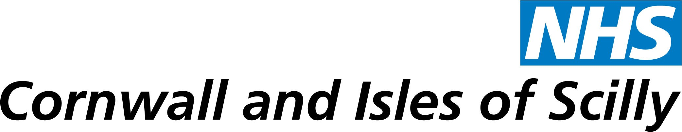

PR068/12/ZH

20 September 2012

SERCO SERVICE ‘SAFE AND EFFECTIVE’ - REPORT PUBLISHED

Cornwall’s primary care trust has today published a report showing that the out of hours doctor service is fundamentally ‘safe and effective’ but has faced clinical staffing challenges and issues with data handling.

NHS Cornwall and Isles of Scilly’s report, published today, includes an independent clinical review by Dr David Colin-Thomè in which he says that the service is safe and effective but acknowledges that Serco, which runs the service, has faced challenges with clinical staffing and service levels in the recent past.

Dr Colin-Thomè has made a number of recommendations which will be considered by the PCT Board at its public meeting next Tuesday (25 September).

The Board will also receive an update on the further work undertaken by Serco looking at its data recording processes. This work has shown that in a small number of cases computer records were changed and there was insufficient justification for those changes. The PCT has been told they were unauthorised and involved 0.2 percent of records between January and June 2012. Serco has apologised and will work with the PCT to strengthen its data handling procedures and controls to ensure consistent reporting in future.

In reviewing the impact, the PCT is clear that the changes were minimal and short-lived.

The PCT will now carry out independent validation of Serco’s report which will be repeated in six months.

Steve Moore, chief executive of NHS Cornwall and Isles of Scilly which commissions the service, said: “I was disappointed to learn that some of the data we received to measure performance was inaccurate although the number of inaccurate records was small.

“I am clear that Serco did not gain from these actions and they have issued a full apology to us.

“I am pleased to say that patient satisfaction with the service remains high and Serco is working constructively with us to address the issues raised by our review. We are confident that their aim is the same as ours, to provide a consistently high quality service to the people of Cornwall.”

ENDS

Notes for editors:
- NHS Cornwall and Isles of Scilly is the commissioner of health services for Cornwall and the Isles of Scilly and will remain accountable for the commissioning of safe, high quality services until its abolition in 2013.
- The report, published on the PCT’s website, includes:
  - up to date performance data for August;
  - results of a recent patient survey showing most patients rate the service highly;
  - PCT and Serco action plans following the CQC inspection and report;
  - a review of whistleblowing arrangements at Serco;
  - recommendations resulting from a survey of local GPs;
  - arrangements for local clinical review of the service; and
  - the independent clinical review by Dr Colin-Thomè.

Media enquiries to:

National media: Zoë Howard on 01726 627892 or 07919 995189
Local/regional media: Emma Corlett on 01726 627811 or 07833 046021

Senior personnel from the PCT will be available for interview.

Please note, out of hours media enquiries should be directed to our main switchboard at Bodmin: 01208 251300. Ask for the duty press officer.

