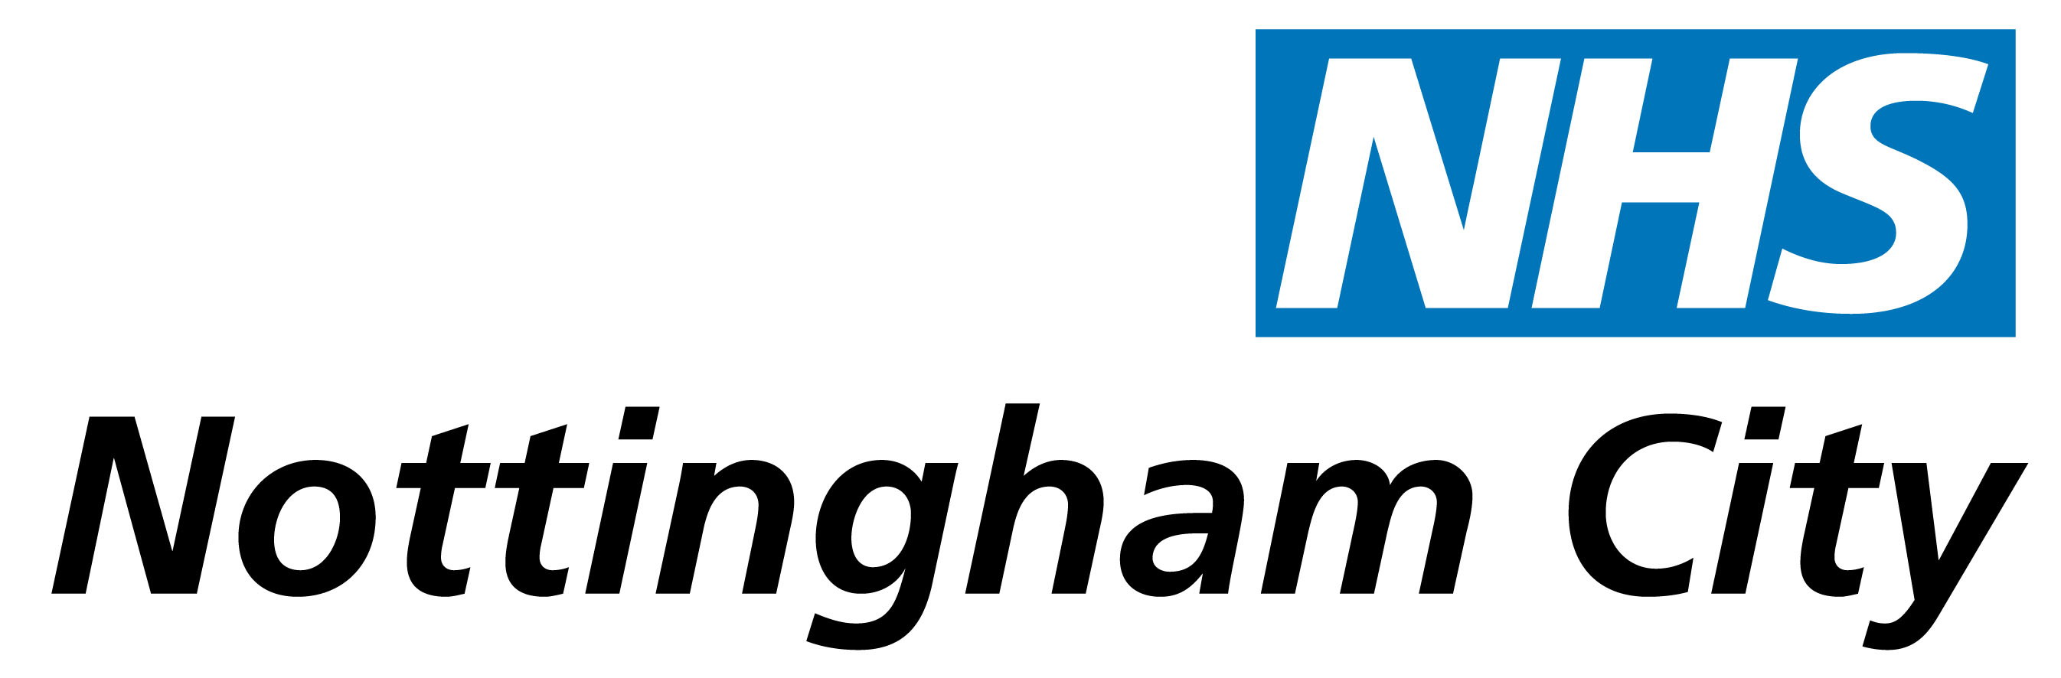

Update on Changes within NHS Nottingham City

- Introduction

The purpose of this paper is to provide an update to the Board on the progress made in relation to the significant transformation programme happening within NHS Nottingham City. The paper focuses on the Transforming Community Services programme and the changes arising from the White Paper – Equity and Excellence – Liberating the NHS

- Transformation Programme

The Transformation Programme, by its very nature, will evolve over time. However, a number of projects have already been established, as follows:

- Transforming Community Services;
- Transition to GP Consortium;
- Transfer of Public Health; and
- Transitional Governance.

Each project has a nominated executive sponsor to lead on its delivery.

- Transforming Community Services

Price Waterhouse Coopers (PWC) are undertaking an independent assessment of the proposal for a social enterprise and will provide a detailed report by the end of February for consideration by a subgroup of the Board on the 9th March.

A Business Transfer Agreement is under development and all service specifications and activity plans have been agreed. Further information and clarification is also being shared with the new providers through the due diligence process and the relevant documentation is under development with a view to sign off by all parties in early March.

There is a possibility of delays in registration with the Care Quality Commission as a result of the large workload for Care Quality Commission arising from the Transforming Community Services programme however all providers have applications in progress and we are assured that there will be no problems.

- Transition to GP Consortium

The management structure to support the NHS Nottingham City General Practice Consortium was published on 10 February 2011. Dawn Smith will be the Chief Operating Officer and the assignment of other staff will take place from 21 March 2011, following a 30 day consultation period. Whilst it is recognised that some staff will have a dual role during the transition in that they will support both the consortium and NHS Nottingham City, the publication of the structure marks a significant step forward in establishing the consortium as a body that is well placed to receive delegated authority from NHS Nottingham City’s Board.

In further support of this, the consortium has commenced its development programme which will assist with the acquisition of the specialised knowledge and skills that will be required of GP leaders. The first session on 16 February 2011 covers the characteristic of an effective Board and the essence of good governance. The event is being facilitated by the Foresight Partnership who have led national work on how to ensure the effective governance of GP Commissioning. Future sessions will cover:-
- Successful financial management
- Procurement processes and dealing with conflicts of interest
- Contracting and performance management and accountability for the quality of commissioned care
- Making partnerships work
- Using public health skills and analysis to drive and target effective commissioning
- Prioritisation of investment and the QIPP challenge
- Influencing and negotiating skills

Work continues to progress with the development of the Articles of Association for the consortium which will set out the rules of engagement with constituent practices and describe the relationship between the GP clusters and the consortium along with their respective decision-making powers.

- Transfer of Public Health

The Health Equality Directorate phase one staff (approximately 20) transferred to the Local Authority based at Loxley House on Tuesday 1 February 2011. On the morning of the move an Induction programme was organised by Nottingham City Council to demonstrate practicalities, Health and Safety and getting to know your new working environment.

To ensure a smooth transition and continue to focus on Health Improvement priorities Public Health have been allocated some funding from the SHA specifically to support Public Health through the transition and will hold a number of Away Day Events together with some Nottingham City Council employees. The first event was held at Colwick Hall on Thursday 27 January 2011 and subsequent events in February and March. The first programme focused on ‘how the Local Authority works’, ‘The Council Plan’, ‘Corporate Communications’, ‘Public Health function in the new world’ and practicalities surrounding the move. February’s session will consider the JSNA and the session in March will focus on Health and Wellbeing Board

Whilst the Health Promotion and Partnership Team will move on a more permanent basis the remaining staff will continue to have a main base in Standard Court and will hot-desk at Loxley House.

- Transitional Governance

The Board and Business Continuity workstream is continuing its work in relation to reviewing the existing governance structures within NHS Nottingham City both as part of the preparation for establishing the shadow GP Commissioning Consortium and as a consequence of the Department of Health document “PCT Cluster Implementation”. This will be discussed at the Board Development Session on 15 February 2011. The workstream has also revised the front sheet to Board papers to reflect the transformation programme.

Work has been ongoing in the Information Governance workstream of which a significant element relates to records management. The workstream has agreed and prioritised the scope of the work and has a pilot project in place to review electronic records management. The findings from the project will then inform the roll-out across the organisation. Additionally confirmation has been received from the National Archives in relation to the place of deposit for NHS Nottingham City records and this now enables a detailed conversation to take place regarding records for the National Archives.

Finally, work continues to identify and action the specific tasks required to deliver a successful transition and wind down, including sharing of plans across organisational boundaries to ensure consistency of approach. Many of the initial keys tasks related to ‘house-keeping’ type activities and these continue to be progressed.

- Recommendations

The Board is asked to:

- Receive, comment upon and endorse this update on the work to date in relation to the transformation that NHS Nottingham City is undergoing.

Chris Packham Dee Sissons
Director of Public Health Director of Nursing and Quality

Dawn Smith Alison Treadgold
Director of Delivery and Performance Executive Lead: Transition

February 2011

PCT Cluster Implementation Guidance, Department of Health: London, Gateway reference 15520

